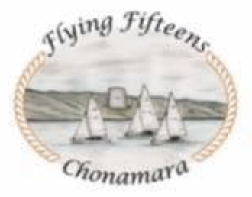 Cumann Badóireachta agus Seoltóireachta An Cheathrú Rua, Co.na Gaillimhe

Flying Fifteens Chonamara
West Coast Championships 22nd and 23rd August 2026
ENTRY FORM
Ros A Mhíl Harbour, Ros A Mhíl, Galway, H91 903H

Name | Helm | Crew
Club
Email
Contact Number
Boat Number
Sail Number (on day)
Spinnaker colour

I wish to enter the above named boat in the Flying Fifteen West Coast Championships 2026. I agree to be bound by the Racing Rules of Sailing, and all other rules that govern this event. I accept full responsibility for the management and safety of the boat noted above and I also accept that neither the Organising Authority, Ros A Mhíl Fishery Harbour Centre, the Race Committee, their members and their representatives shall accept any liability for material damage or personal injury or death sustained in conjunction with or prior to, during, or after the regatta.
I declare that I hold a valid and current Certificate of Insurance with adequate third party cover, which includes cover while racing
Yes __ No __
I enclose my payment Yes__ No __
HELM SIGNATURE: ______________________________ DATE: ________________________
CREW SIGNATURE: ______________________________ DATE: ________________________
N.B. For entrants under 18 years on the date of the race, this form and the declaration above must also be signed by a responsible adult, parent, or guardian
 | Signature | Mobile Phone Number
Name Responsible Adult
Date:

Entry Fee
Entry fee: €110.00 per boat to be paid before Wednesday 19.08.2026
Dinner is optional but must be paid in advanced cost €30
Yes ___ I wish to book ___ places for dinner (number of attendees)
No ___ I won’t be attending the dinner

Entries payable to flying fifteen Chonamara:
Please reference boat number/ owner on payment
Iban: IE45AIBK93740133540061
SORT CODE: 93-74-01
ACCOUNT NUMBER : 33540061
Email: flyingfifteenschonamara@gmail.com
Contact Niall O Brien on 087 4188557

